STATIC CODE ANALYSIS WITH FINDBUGS

EC 5080 – SOFTWARE CONSTRUCTION

WIJAYAWARDHANA W.A.H.A.

2019/E/166

SEMESTER 05

19 NOVEMBER 2022

**STATIC CODE ANALYSIS WITH FINDBUGS**

What is static code analysis?

Testing the code quality through scanning the source code is define as static code analysis. This use to find the potential errors before run an application under test.

In static code analysis debugging is happen automatically by examining the source code without execute the program. This use to understand the code base and ensure the code is compliant, safe and secure.

Why we need static code analysis?

The main reason of using static code analysis is allow to thoroughly analyze all of the code without even running the code.

Enhance your code review quality, cost saving are the other advantages coming through this static code analyzer.

Static code analysis cannot use for find bugs in business logic.

**FindBugs**

FindBugs is an open source tool use to perform static analysis on java coding.

For Intellij IDEA also these a plugin for using the findbugs method. Also for other code ID also have plugins for each one.

FindBugs methods:

* Standalone mode.
* Maven plugin.
* Integration with CI tools.

FindBugs:

Findbugs scan the possible bugs in a java program. The finding errors shown as warnings here. Each warning do not much effect on the program.

Before running the program we can use this findBugs plugin and that will show what are the errors and warnings occur if we run the code so this is very useful to identify the errors and warnings for programmers.

**Install FindBugs plugin in Intellij IDEA**

Go to settings -> Plugins

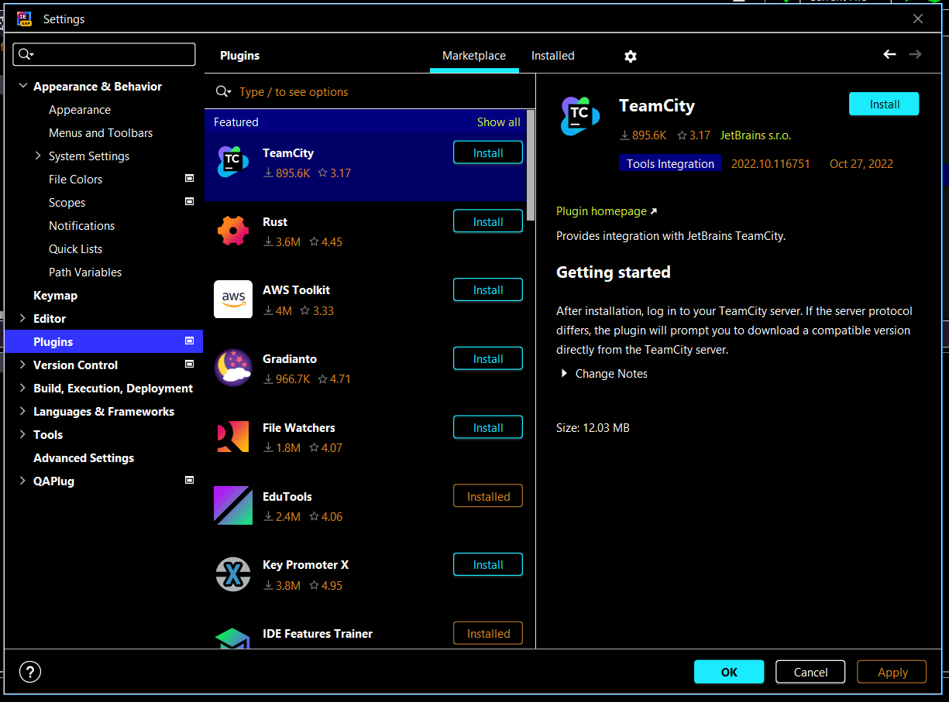

Search for FindBugs and install it

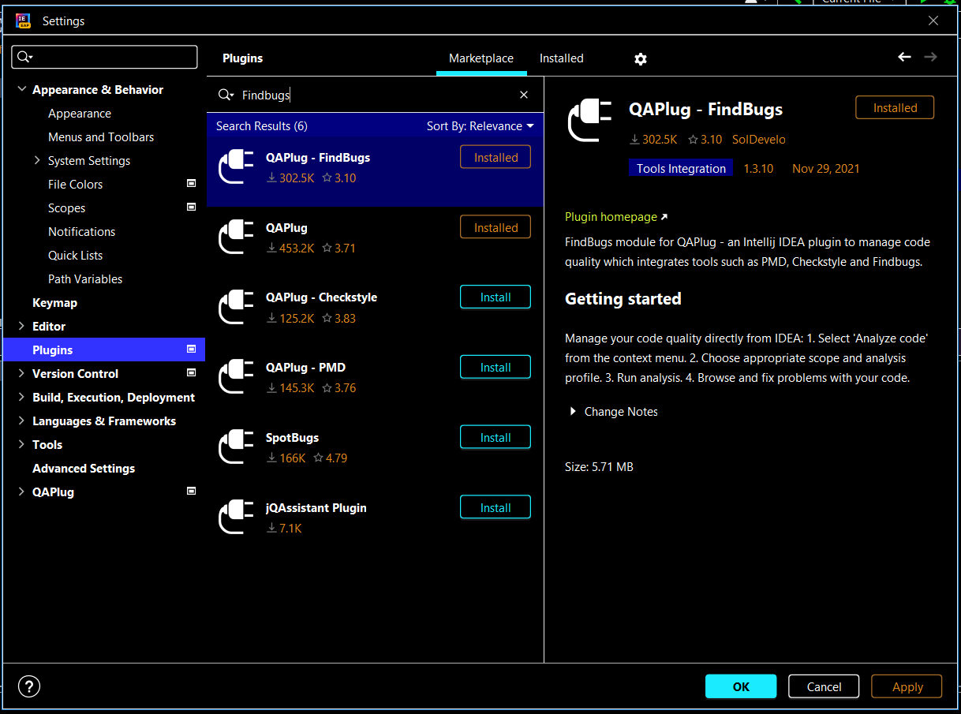

**How to handle findBugs**

After write the code:

Right click on project -> Analyze -> Analyze Code

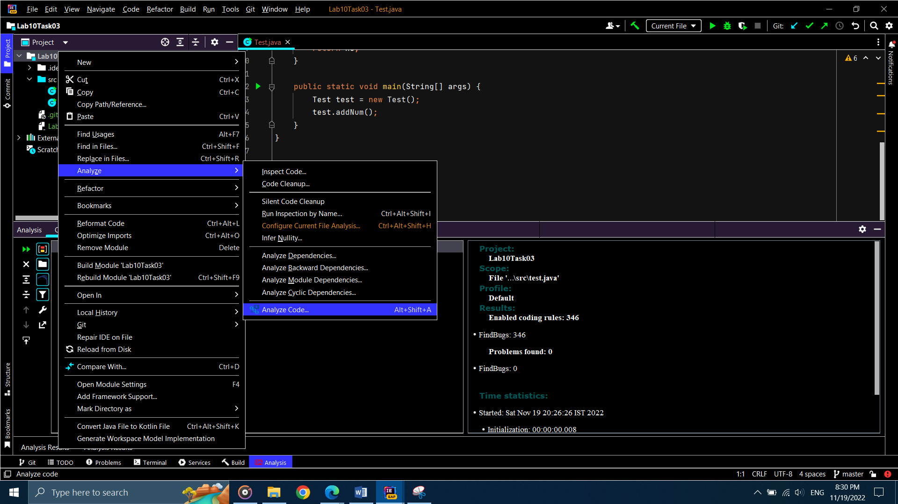

The output will come like this:-

